SCREEN SHOTS using SWAGGER

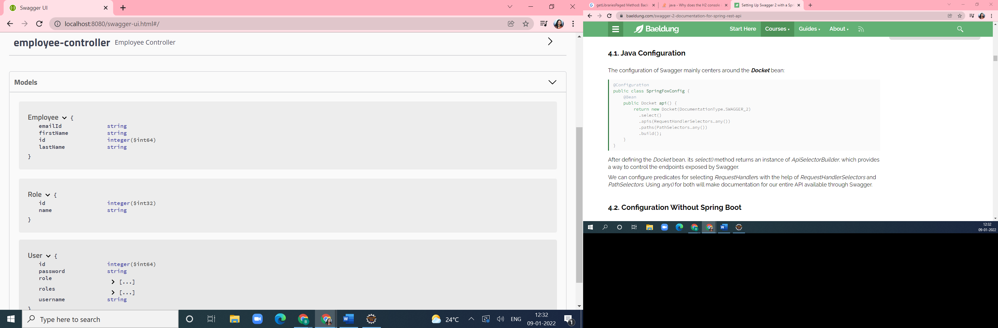

DIFFERENT OPERATIONS DOEN ON EMPLOYEE FILE

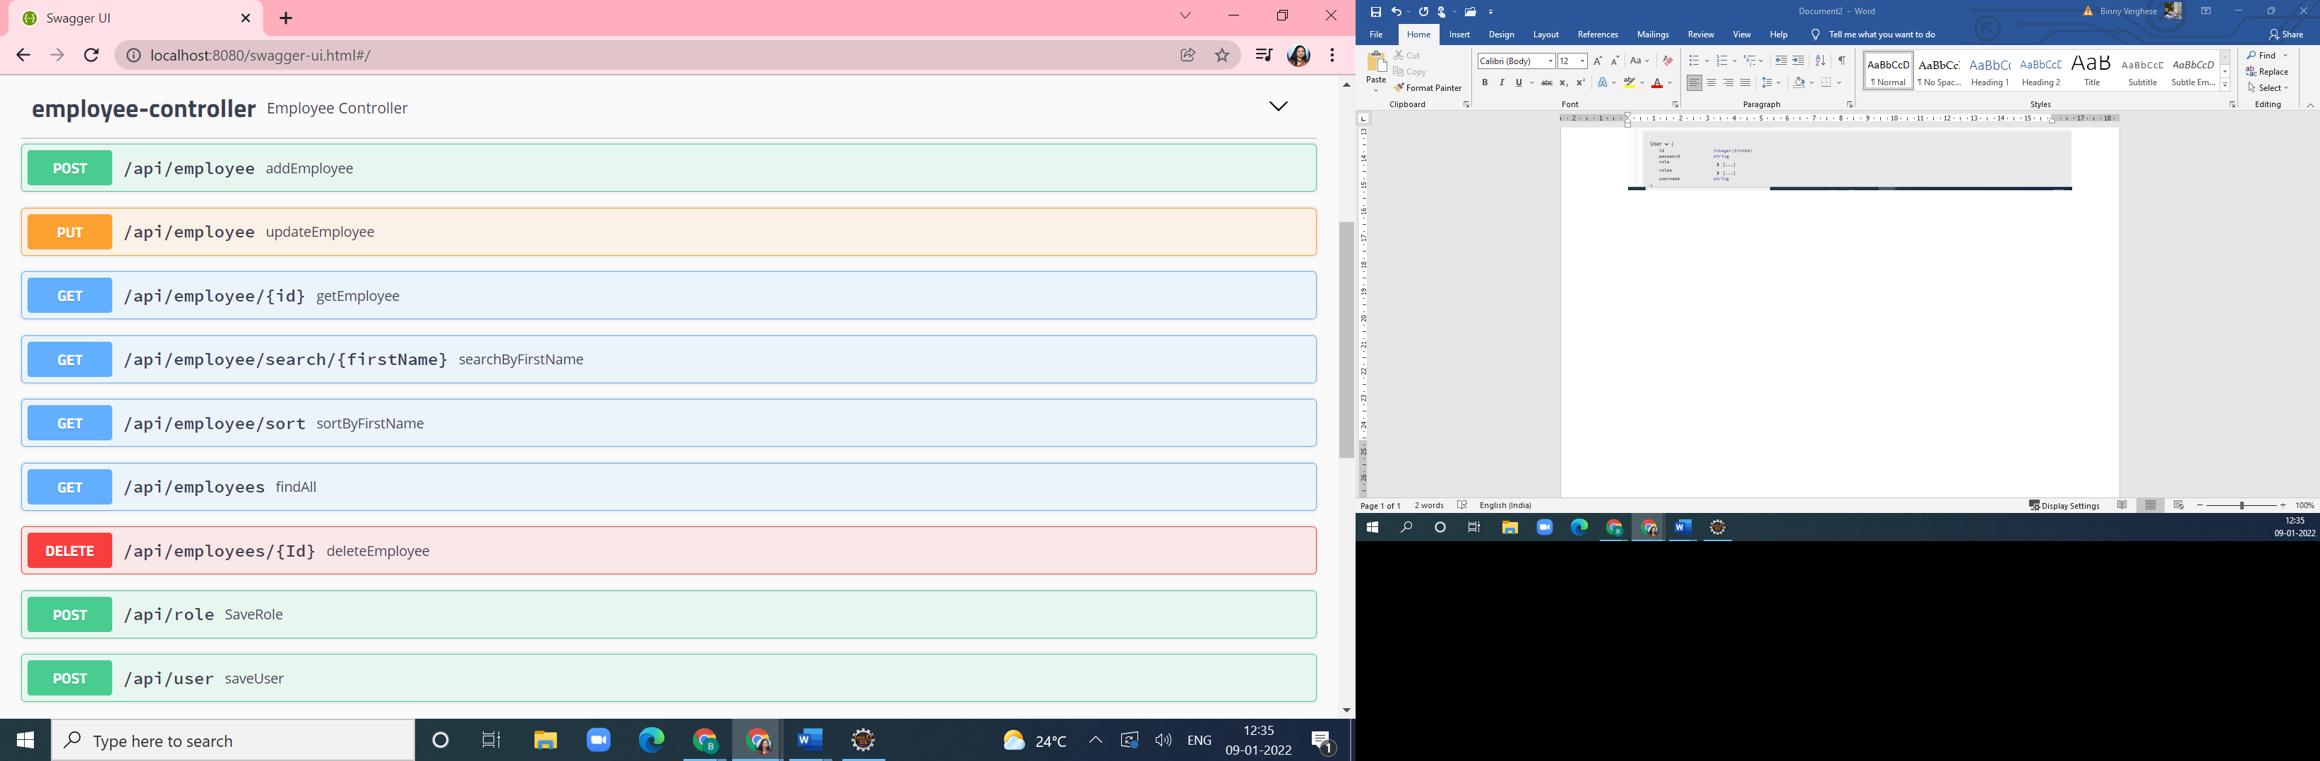

Add an employee

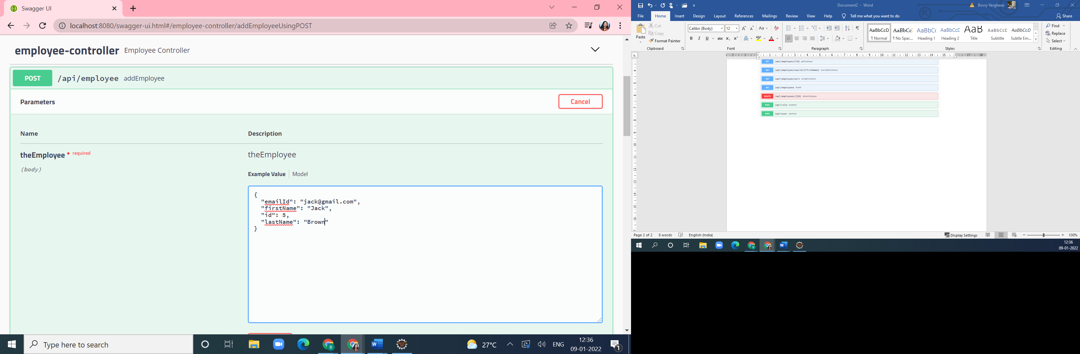

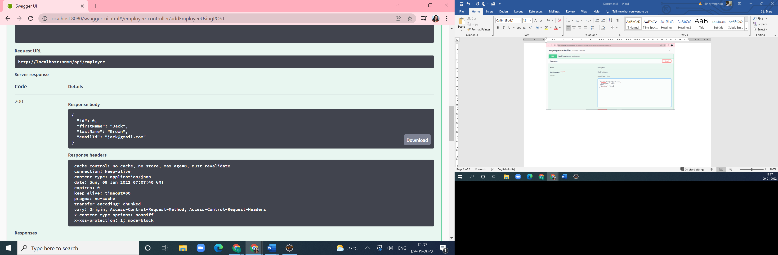

Employee is added

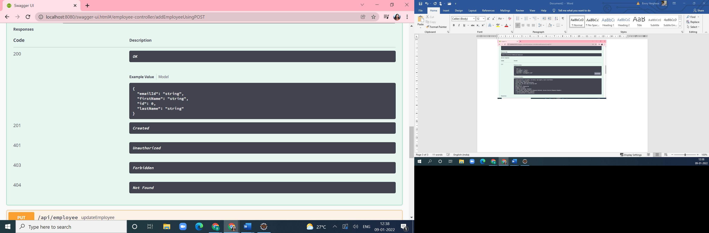

Seen as in the h2 database – Employee table

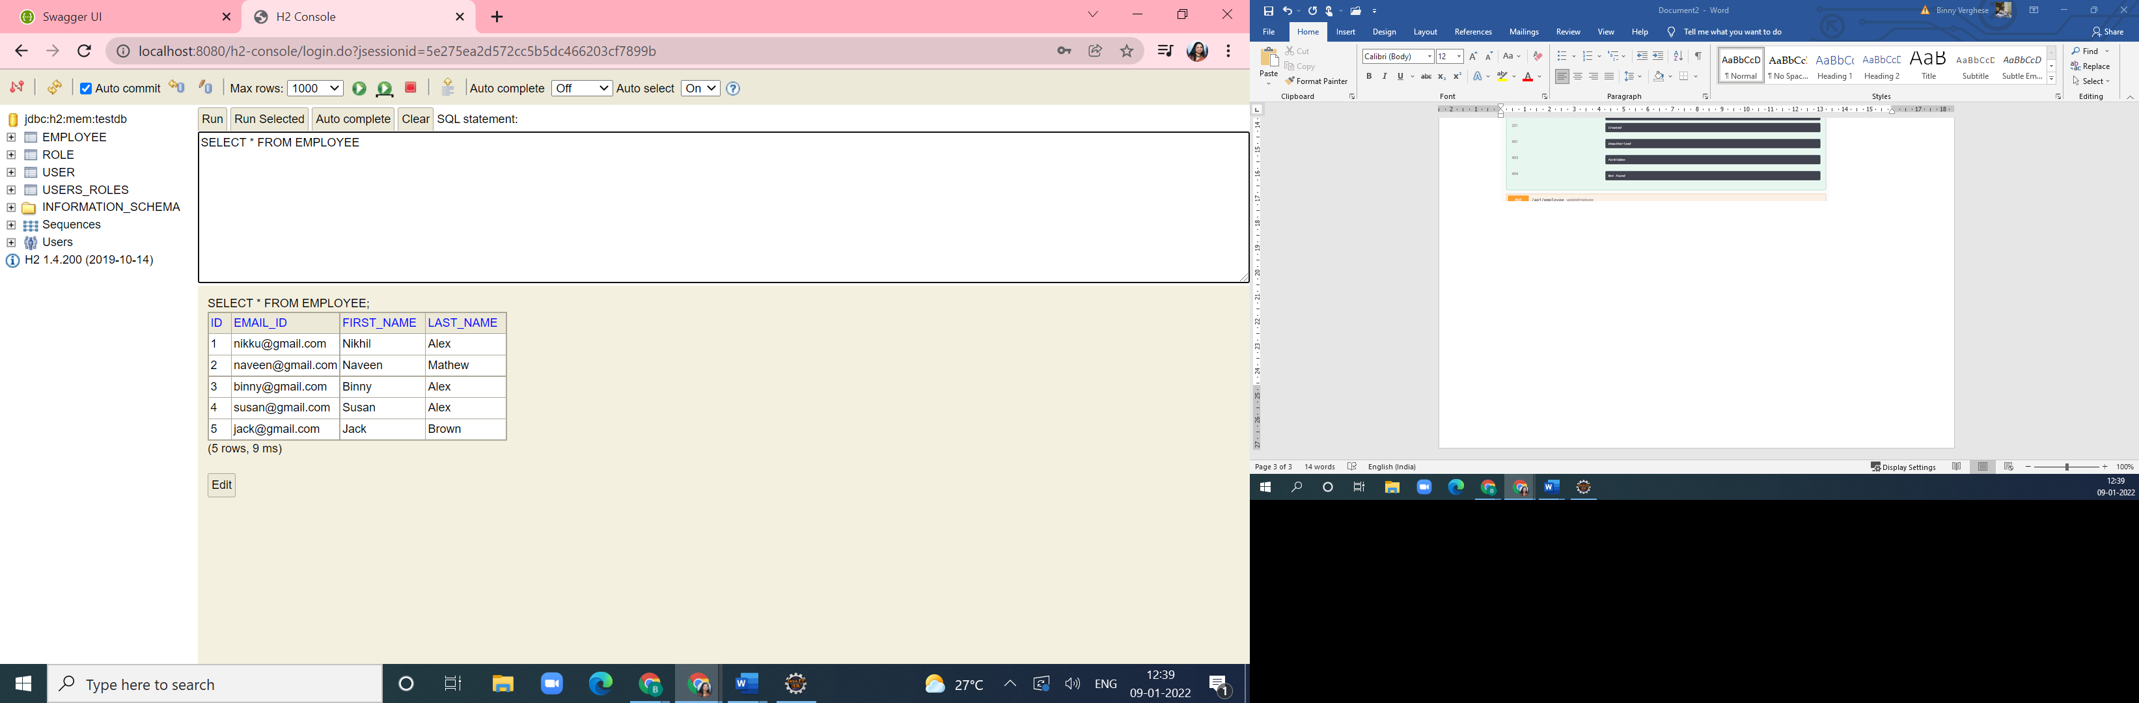

UPDATION of Jack Brown EMPLOYEE

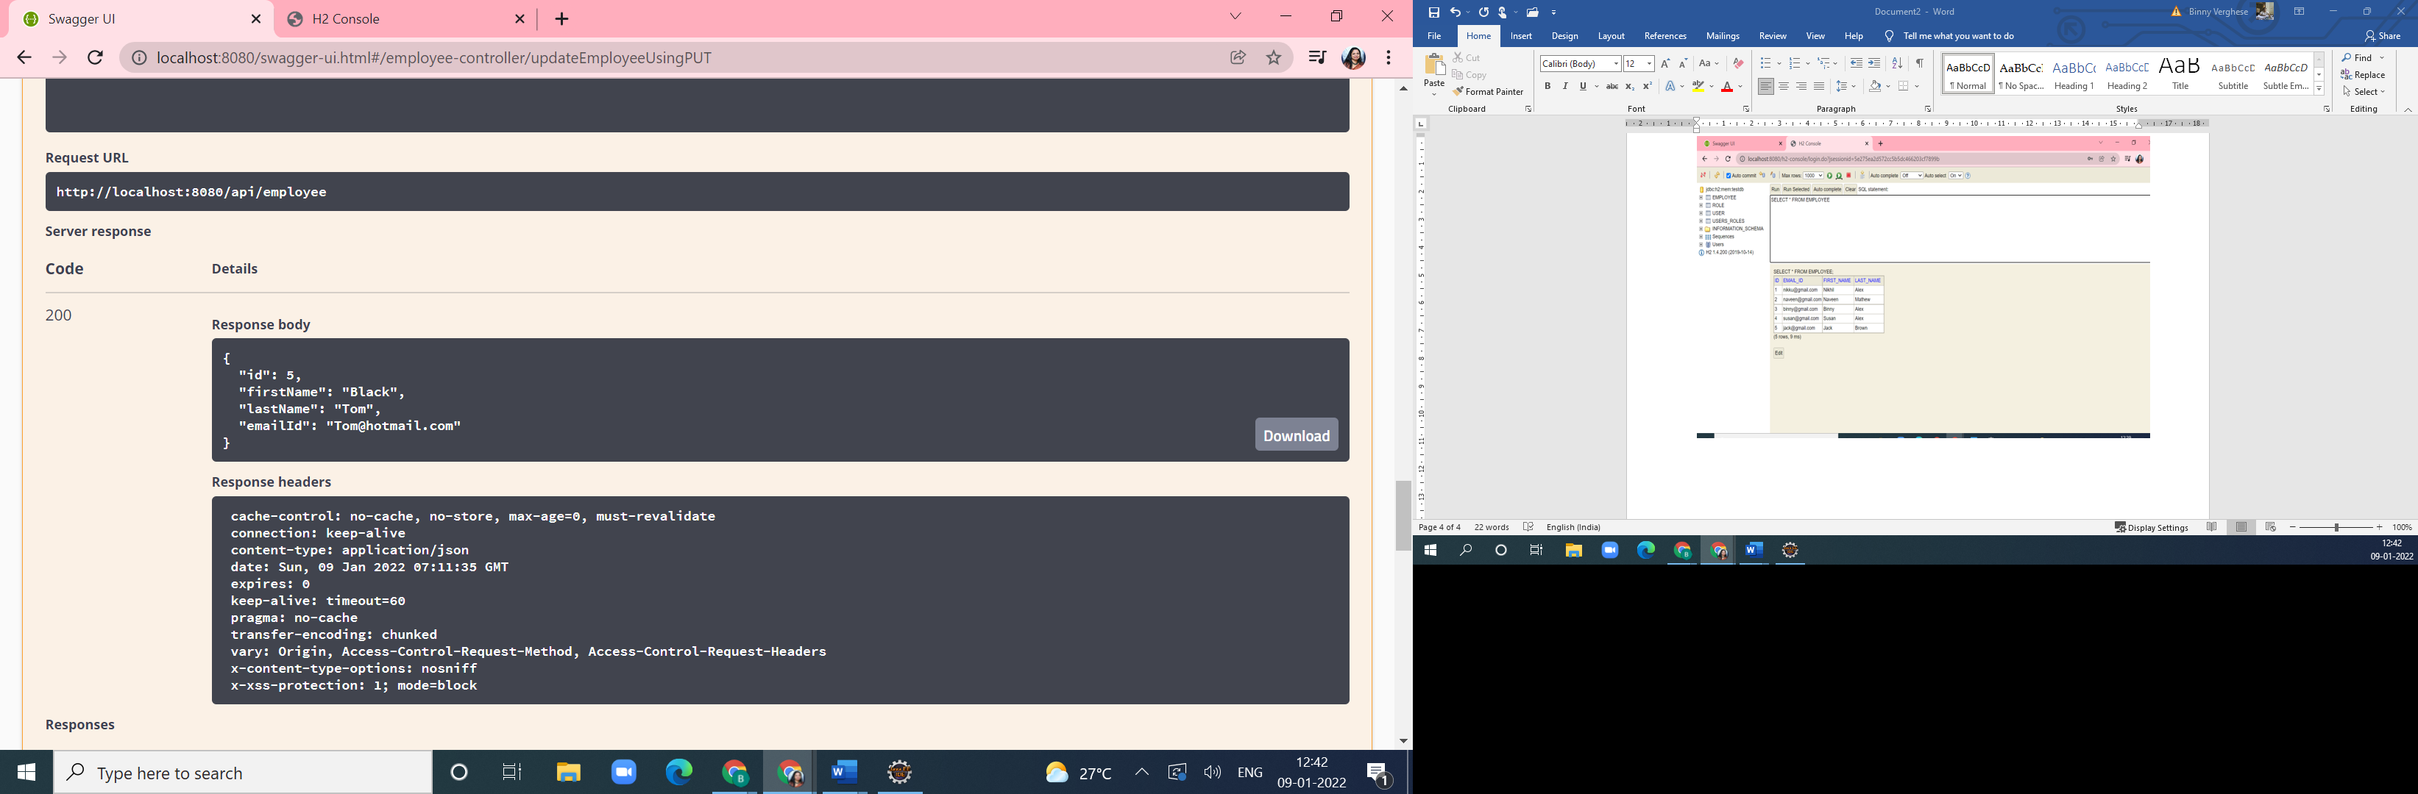

Reflected in the table

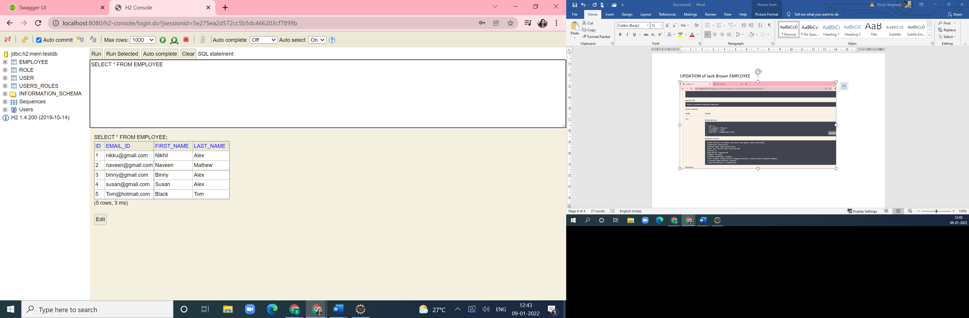

SEARCH BY FIRST NAME – searching by the NIKHIL

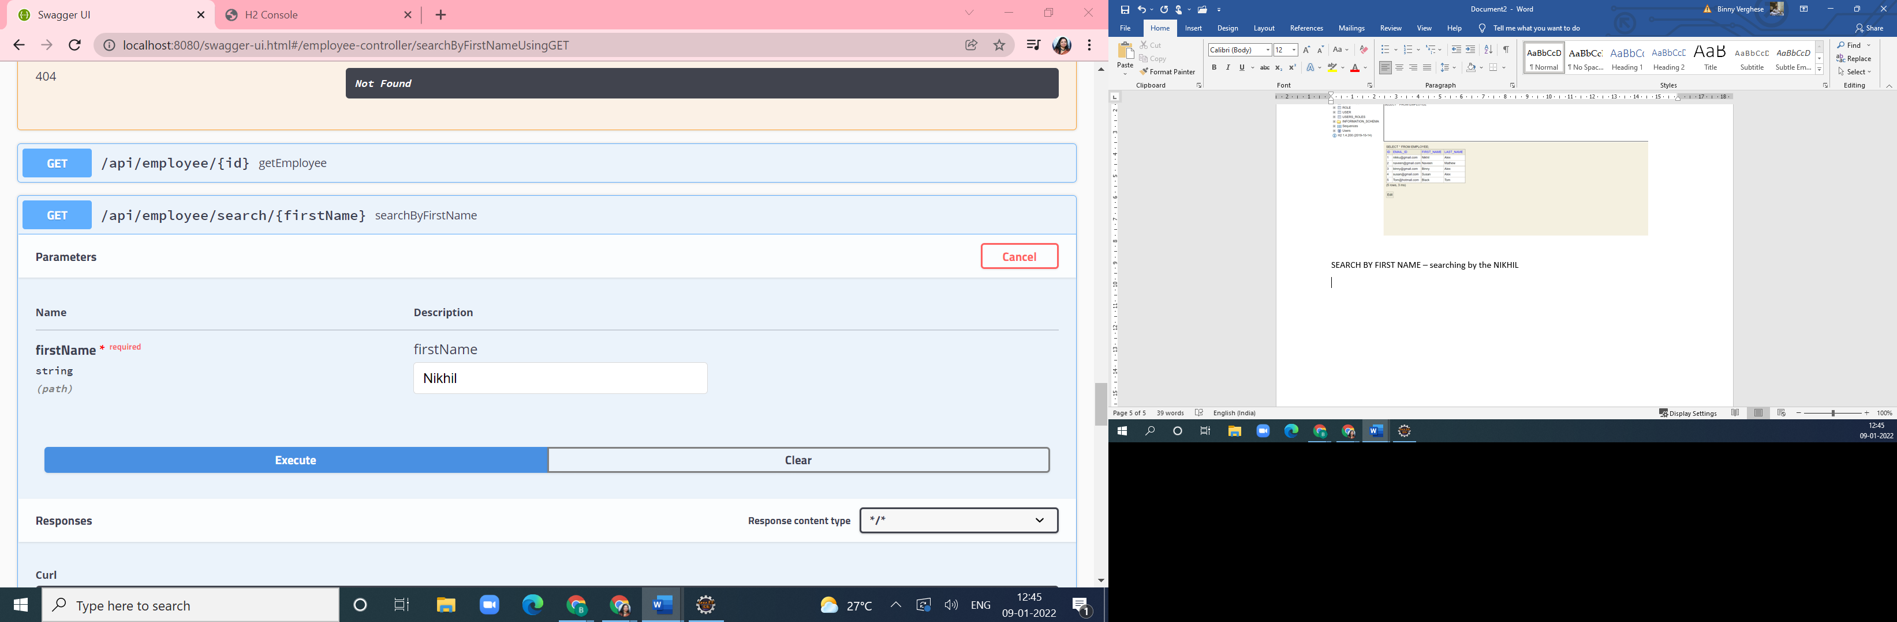

RESULT

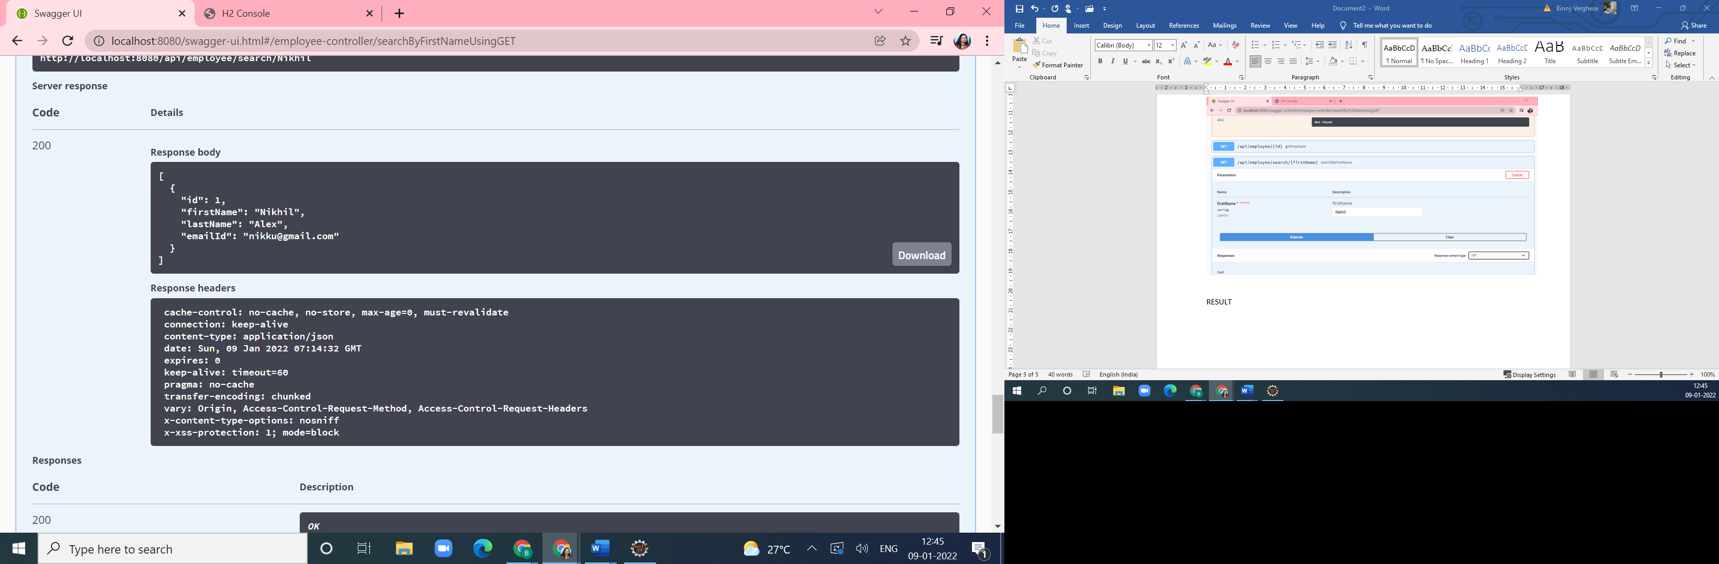

SORTING BY FIRST NAME

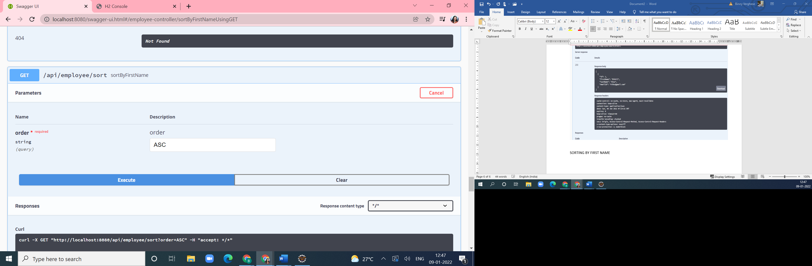

LIST OF RECORDS SORTED IN ASCENDING ORDER

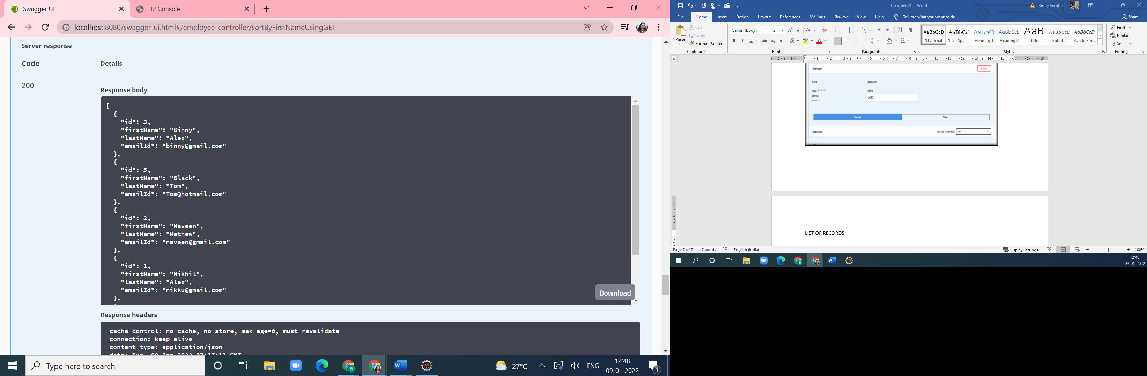

DISPLAY ALL RECORDS

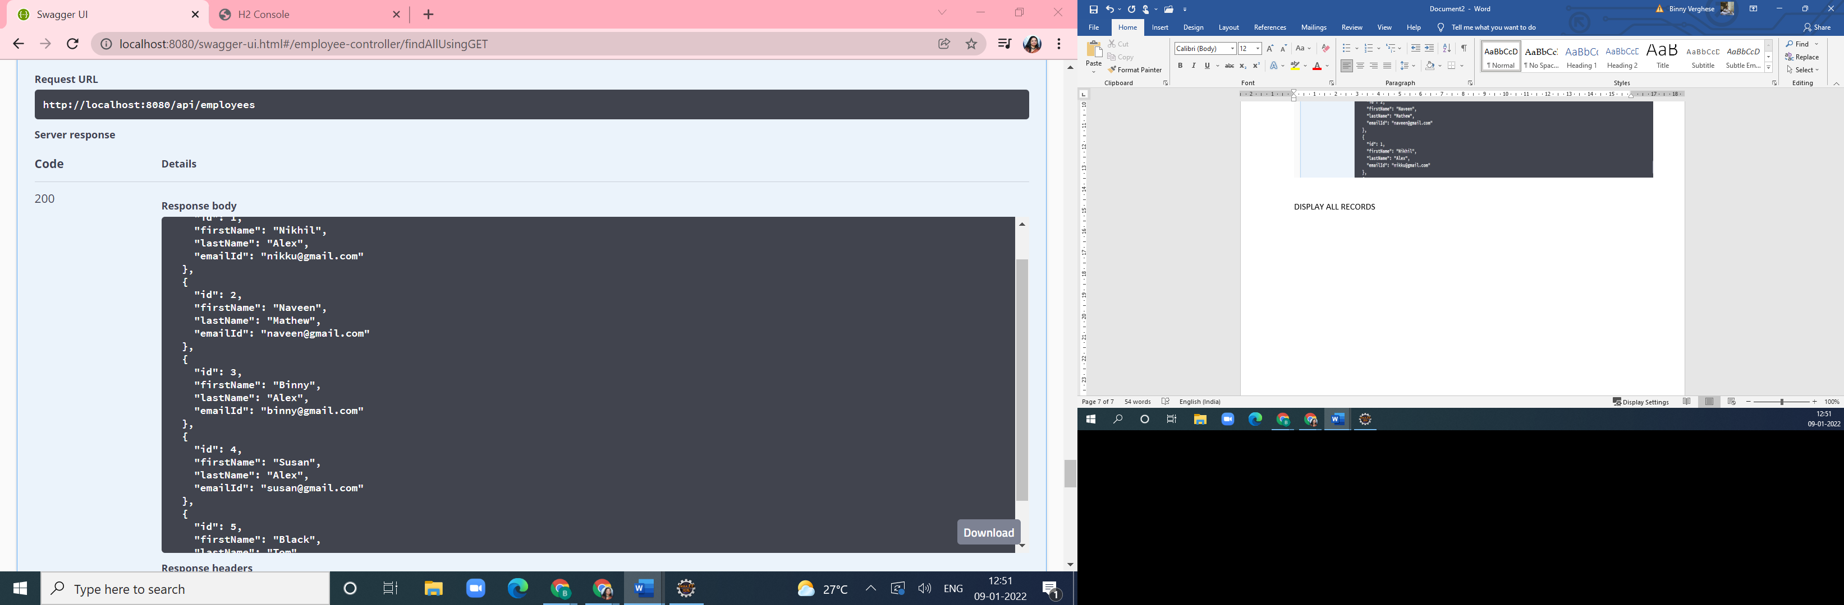

ADDING NEW USER

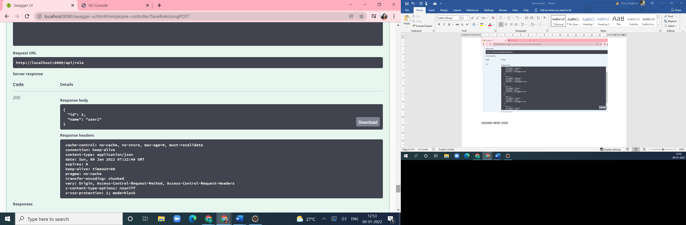

(ADDED USER CALLED USER2)